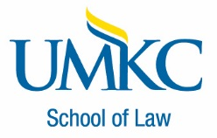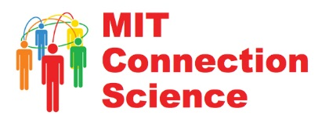

**Brooklyn Law School’s Geraldo’s Café at Feil Hall, 205 State Street, Brooklyn, NY 11201**

**Program Schedule**

**9:30-9:35AM: Welcome, Introductions and Overview of Attendees and Program**

* Tony Luppino, UMKC School of Law, Co-Moderator
* Jonathan Askin, Brooklyn Law School, Co-Moderator

**9:35-9:55AM: Program Kick-Off**

* Kathleen Garman on behalf of the Honorable Sly James, Mayor of Kansas City, MO
* Gale Brewer, Manhattan Borough President
* Ben Kallos, New York City Council Member

**9:55-10:55AM: Examples of Cities & Law Schools Collaborations:**

***Projects-Based Courses (9:55-10:15AM)***

* Dean Ellen Suni and Michael Robak, UMKC School of Law, and Rick Usher, Assistant City Manager, Kansas City Missouri
* Ryan Calo and William Covington, University of Washington School of Law, and Jan Whittington, University of Washington Urban Planning and Design and Center for Information Assurance and Cybersecurity College of Built Environments

***Legal Hackathons, Prototype Jams, and Legithons (10:15-10:35AM)***

* Jeannette Eicks, Vermont Law School
* Dazza Greenwood, MIT Media Lab

***Smart Cities & Research & Policy Initiatives (10:35-10:55AM)***

* John Cummins, Queen Mary University, London, UK
* Kathleen Garman, City of Kansas City, MO

**10:55-11:25AM Multi-Cities Initiatives**

* Evan Absher, Ewing Marion Kauffman Foundation
* Paul Barham, Code for America Brigade
* David Zvenyach, FreeLawFounders

**11:25-11:45AM Open Discussion of Cities & Law Schools Consortium Value Proposition**

* All Attendees (facilitated by Tony Luppino & Tokumbo Shobowale)

**11:45AM-1:00PM Lunch Break/Networking**

**1:00PM-1:45PM Open Discussion of Potential Consortium Objectives/High Priority Projects**

* All Attendees (facilitated by Dean Ellen Suni & Dazza Greenwood)

**1:45PM-2:30PM Open Discussion of Consortium Operational Design, Resource Needs and Next Steps**

* All Attendees (facilitated by Tony Luppino & Jonathan Askin)